# Rocket Equation

Let

* V(t) the speed of the rocket.
* m(t) the mass of the rocket.
* b the coefficient of friction.
* $v_{e}$ the speed of the exhaust.
* P the momentum of the rocket.

P = m(t) v(t) $→$ dP = dm v $+$ dv m

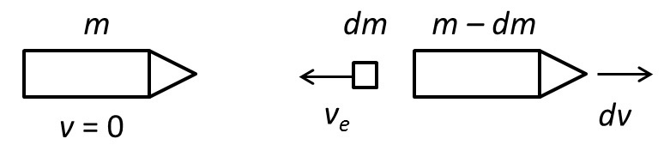

Since momentum is zero in the left panel and is conserved, the total momentum in the right panel must also be zero, which means the leftward momentum of the ejected mass must equal the rightward momentum of the rocket:

dm $v_{e}$ = (m $-$ dm) dv (conservation of momentum)

$-dm v_{e }$ = dv m

The change in momentum during the interval $ dt$is

Change in momentum = ${momentum }_{final }+{momentum }_{initial}$

dP = dv m $-$ dm $v_{e}$

Friction, gravity and pressure:

$$∑F=\left(P_{e}-P_{0}\right) A-D-mg cos⁡(θ)$$

Applying conservation of momentum:

dv m $-$ dm $v_{e}$ = [ $\left(P_{e}-P_{0}\right) A-D-mg cos⁡(θ)$] dt

for $\left(P_{e}=P_{0}\right)$:

$\frac{dv}{dt}$ m = dm $v_{e}$ $-$ D $–$ mg cos ($θ$)

for D = b v^2, $θ=0$:

dv m = $\frac{-dm}{dt}$ $v_{e}$ $–$ b v^2 $–$ mg

$\frac{dv}{dt}$ = $\frac{-dm v_{e} }{m dt}–$ $\frac{b v^2 }{m}–$ g

$\frac{dv^{'}}{dt^{'}}$ = $\frac{-dm T_{0} }{m dt}–$ $\frac{b{ T}_{0} v^2 }{m v_{e}}–$ $\frac{g T_{0}}{v_{e}}$

Let

$${m^{'}}_{0 }= \frac{m_{0}}{bv_{e }t_{0}}$$

where {v'=v/ $v_{e}$} and {t'=t/ $t_{0}$}. Now l{m(t) = $m_{0}$ z(t)} where $m_{0}$ is the initial mass of the rocket. If the rocket decreases to 1/10th its mass after $t_{0}$ it follows that z(t'=0) =1 and z(t'=1) = 1/10.

z(t'), the function that quantifies how fast the mass of the fuel is depleted.

Here we will use z(t') = 1 $-\frac{9}{10} t^{n}$

so that n specifies how fuel is disposed